Homework 1

Leow Yong Kang Andrew A0188377L

**1.** 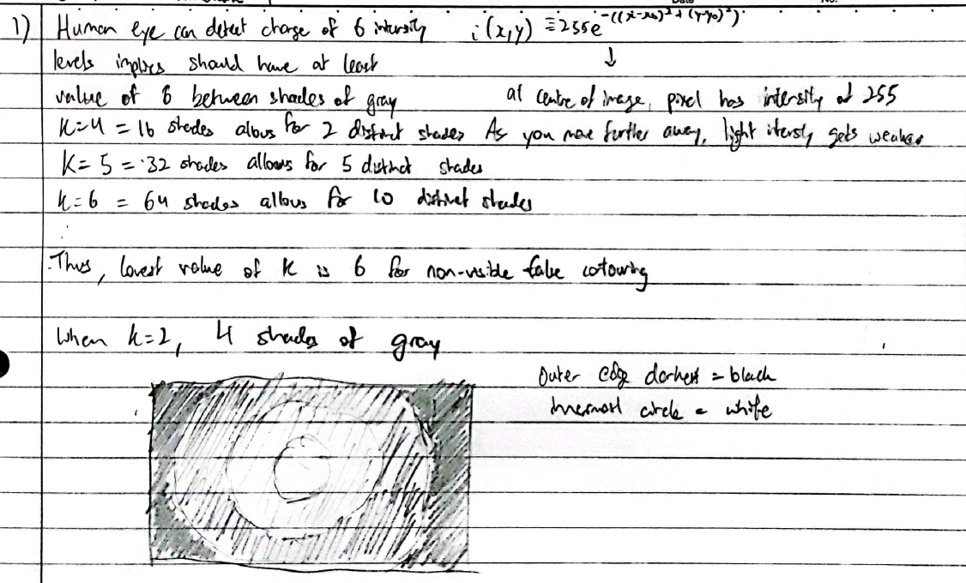

**2.** 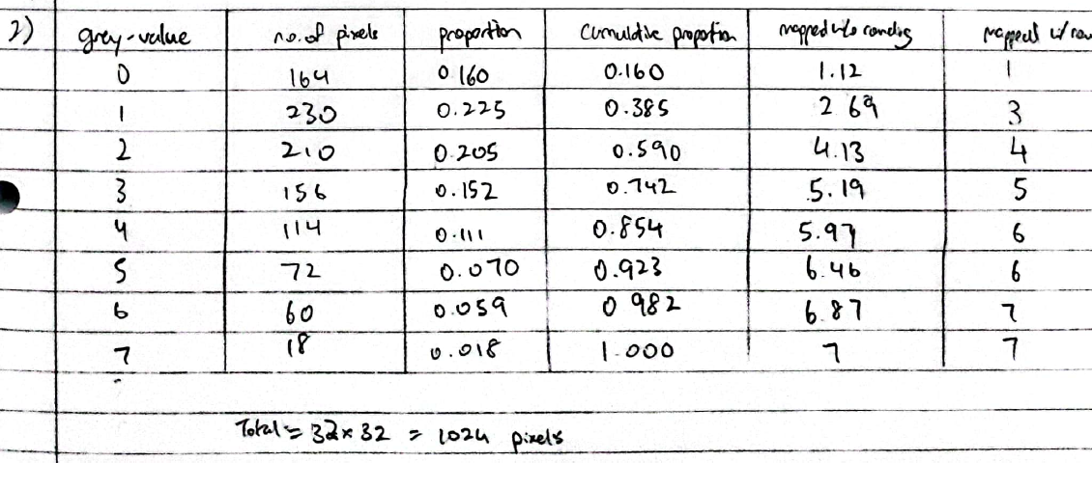

**3.** Using a box filter of size 25 will ensure that for every pixel in the image, there will be always 5 pixels width worth of black pixels considered in the image region. This is because the thickness of the bars and distance between bars add up to 25 exactly, such that the image region will always overlap on 5 black pixels. This would then smooth the intensity of the bars across the image region at the same intensity level throughout the image, as 5 pixels width of black bars are included in every image region. This gives a relative intensity of 20/25 = 4/5.

In the case of the box filter of size 45, the number of black bars included in each image region will vary between 1 and 2.

Consider the case where pixels from one bar is included: this occurs when the image region starts from the start of one of the white regions, leading to 20 white + 5 black + 20 white pixels in the image region. This gives a relative intensity of 40/45 = 8/9 over the 45 pixel wide region

Now, consider the case where pixels from two bars are included: this occurs when the image region starts from one of the black bars, leading to 5 black + 20 white + 5 black + 15 white pixels. This would give a relative intensity of 35/45 = 7/9 over the 45 pixel wide region.

The difference in relative intensity levels gives rise to the appearance of distinct “bars” in d), whereas the image in c) will have all its intensity levels equalized to 4/5 of the lightest region.

**4.**

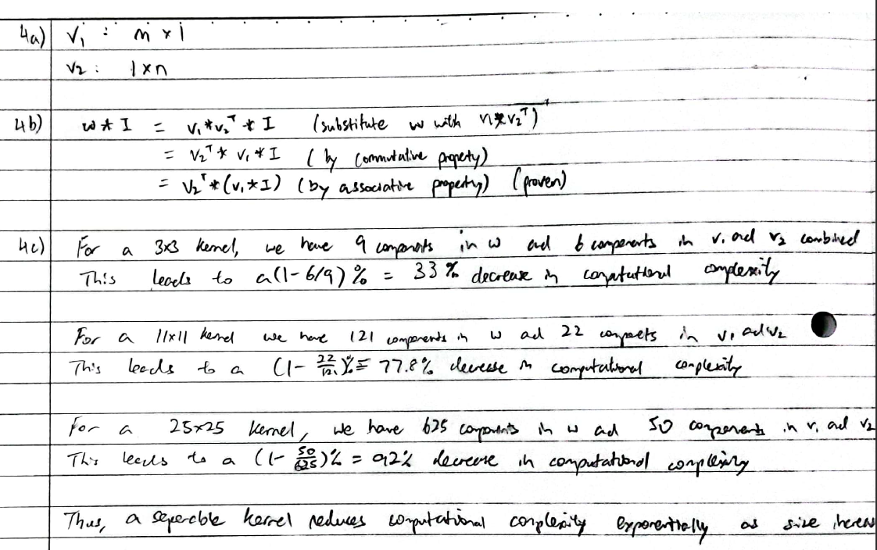

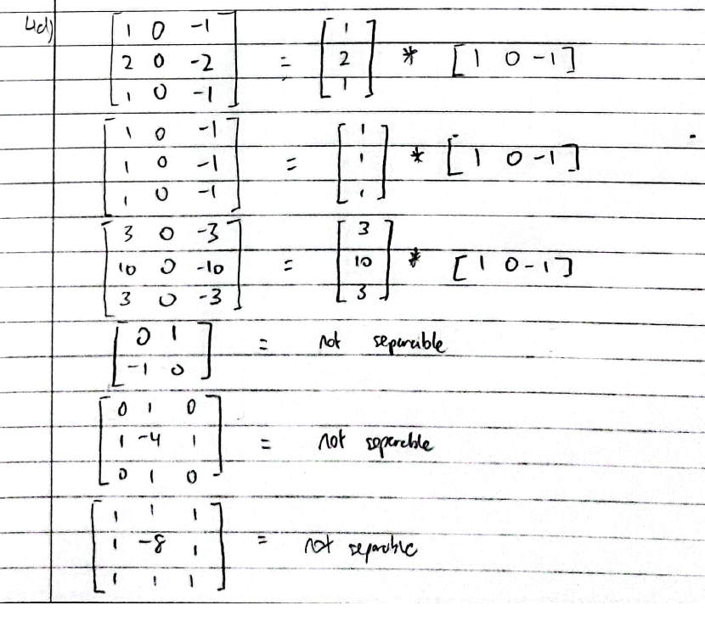

**5.** 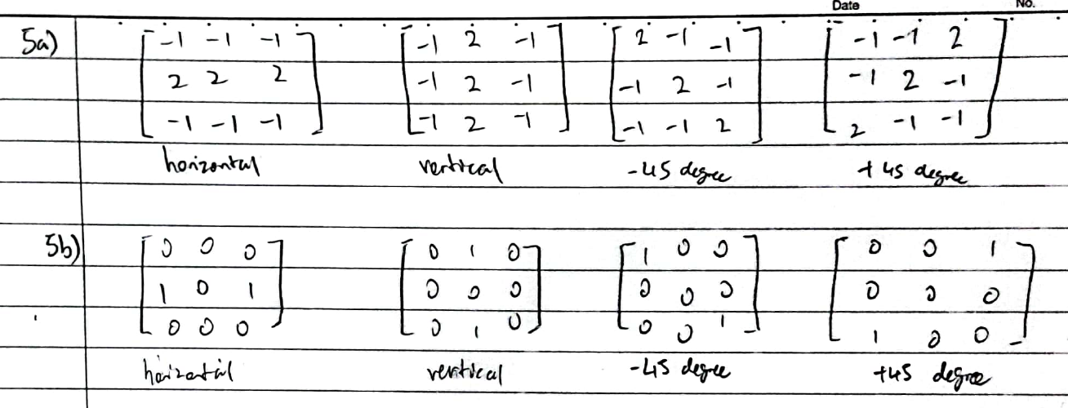

**6.** 